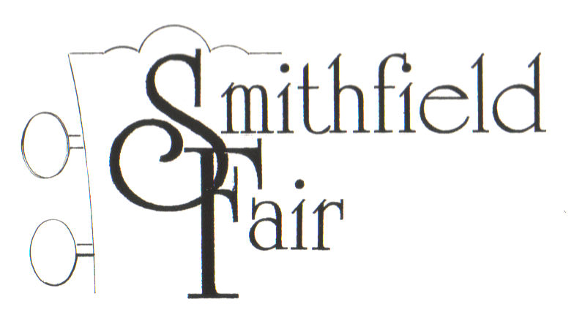
S m i t h f i e l d F a i r (2016)
Forty-three Years of uncommon music

In a storied career now in its fifth decades, Smithfield Fair has composed, recorded and performed music for television, movies, radio, promotions, broadcast and, most importantly, live performance. Begun in Pensacola, Florida in 1973, the group focused on original songs deftly woven over acoustic accompaniment. In 1974, it was signed to Nashville-based GWS Records and was soon recording in Nashville with famed producer Bud Reneau (Dobie Gray, Quad Studios) and engineer/drummer Gene Lawson (Lawson Microphones, Lonnie Mack). In a common music industry story, that record was never released. However, the group's first released single, A Place In Your Heart/Goodbye Old Friend in 1977 was on Floyd Soileau's now-internationally renowned Flat Town/One Way Records. The group would then found their own independent label in time for their first album in 1981, Only The Wind. With the release of MARBLES in 2015, Smithfield Fair has to date released 30 albums of original and traditional music.
Smithfield Fair’s uncommon music is folk-based, but awash with elements of swing, gospel, Celtic, blues, and swamp pop, attesting to their upbringing in the musical crossroads of the deep south. Often difficult for reviewers to effectively pigeon-hole, Smithfield Fair has been termed “a folksy Supertramp”, “an un-updated Peter Paul & Mary”, having “a definite Peter Gabriel vibe”, “ echoes of the Weavers,” and “the perfect café band” among many tags. An impressive list of performances includes the World’s Fair, Kerrville Folk Festival, New Orleans Jazz & Heritage Festival, Stone Mountain (Georgia) Games, Carolina Celtic Fest, Dallas International Festival, North Texas Irish Festival, and such legendary venues as Houston’s Rockefeller’s and Anderson Fair, Pensacola’s RadioLive, the New Orleans' Storyville Jazz Hall, and even several Chef John Folse Food Channel series. They have appeared in concert with John Prine, the Washington Squares, John Fahey, Jesse Winchester, Alasdair Fraser, Eileen Ivers, Louisiana’s LeRoux, Nanci Griffith, Arlo Guthrie, Zachary Richard, Alasdair Fraser and many others.
No stranger to world-wide airplay, Smithfield Fair’s music is regularly heard on conventional, satellite and internet radio programs, including Pandora and Syrius/XM. Known for their “blood harmonies”, driving acoustic rhythms and memorable melodies, reviewers have long commented that Smithfield Fair’s original songs stand up strongly with traditional material and “meld into a cohesive whole”.
Smithfield Fair presents a variety of original songs and traditional adaptations that transport listeners out of their day-to-day with a hopefulness and a reflection on better times and themes. The group’s sound is often momentarily reminiscent with an immediacy and intimacy that, given the group’s passionate delivery, has made them a constant audience favorite. The combination of Jan Smith (vocals, accordion, guitar), Bob Smith (vocals, acoustic bass, percussion) and Dudley-Brian Smith (vocals, acoustic guitars, mandolin, recorders) is like no one else.
Find more information on the web at www.smithfieldfair.com, or on Facebook and You Tube (www.youtube.com/smithfieldfair). Photographs of Smithfield Fair are available for download at http://www.smithfieldfair.com/promo/
###

WHAT’S BEEN SAID ABOUT SMITHFIELD FAIR

Playing original works highlighted by otherworldly vocals and nuanced acoustic arrangements; a “Southern folky mix” tinged with jazz, swing, blues and gospel to satisfy their inner cravings. Smithfield Fair looks to be right at home on the Jazz Fest stage. The music veterans will be one of the highlights of the big event in the Big Easy. - AXS Music

One thing about longevity is that you get to take a good look at life. (Smithfield Fair has) learned how to take their life experiences and spin them into musical stories. Their musicianship...is crisp and clean, and the harmonies are sweet as “hot buttered biscuits with syrup, yes, ma’am.” - Significato Magazine

Smithfield Fair manages to entrance the listener with beautiful melodies, stunning vocal performances and brilliant rhythms. - FolkWorld( Europe)

Universal messages, universal stories, but told in a unique and original way. Smithfield Fair continues to grow finer with each passing year. - Ceilidh Magazine

Smithfield Fair, an almost-impossible-to-categorize folk/roots band has mesmerized audiences worldwide over the radio, television, film, clubs and concert halls...has earned praise for its tight arrangements, elegant song selection and some of the most haunting vocal harmonies this side of heaven. - GrisGris Magazine

From the sounds of it, Smithfield Fair seems to be walking through this world just fine, thank you, and savoring every minute of it. – Offbeat Magazine

…much like a folksy Supertramp. … They’re well worth the price if you have the chance to see them perform. – U.S. SCOTS Magazine

